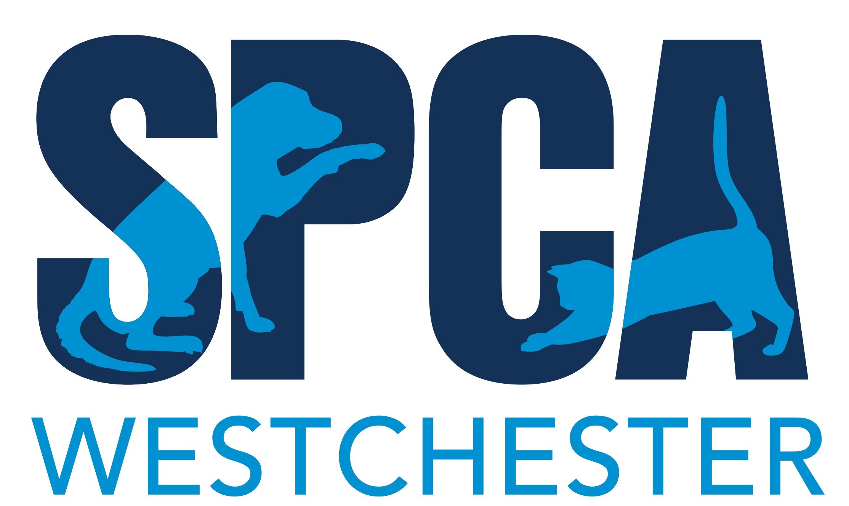



Attendees can take part in a 1-mile trail walk and then enjoy music, refreshments, animal related demonstrations and shopping in our Woof and Meowtown Village, as well as an SPCA adoption fair.

This event is highly promoted through our social media pages (75,000 fan/followers), email blasts (25,000 subscribers), the SPCA’s website (30,000 views per month) and through a special mailing (10,000 supporters/adopters).

2022 SPCA Dog Walk &
Pet Fair Vendor Form

After 2 years virtual, we’re back! Join us on Saturday, May 21st from 10 a.m. to 1 p.m. at FDR State Park in Yorktown Heights.

The SPCA Dog Walk and Pet Fair is the largest pet related event in Westchester County. The goal of this special event is to raise awareness and much needed funds for the more than 4,000 animals the SPCA supports every year.

Adopters and supporters are invited to attend with their canine companions and encouraged to collect donations. Vendors are invited to set up a booth space to promote and/or sell items. Please note, you do not have to be a pet-related business to take part!

Please see the information on the next page regarding a Certificate of Insurance and the necessary language. This certificate is required in advance of the event and should be emailed to Lisa@spcawestchester.org at least two weeks prior.

*The SPCA Dog Walk and Pet Fair is subject to change.
This event is rain or shine, no refunds.


Dog Walk & Pet Fair Vendor Form:
(please keep a copy of this form for the rules and insurance language)

Name:______________________________________ Company:________________________________________

Street Address:__________________________________________Town:_________________________________

State:______Zip Code: ____________ Phone: ____________________Email: ____________________________
Vendor Fee is $200. Checks should be made payable to SPCA Westchester.
Charge my credit card: #_________________________________________Exp:_________CVC Code:_______

Please send form along with payment information to:
SPCA Westchester at 590 North State Road, Briarcliff Manor, NY 10510

Rules and Details:

- The event takes place in the field next to parking lot #1
- Set-up begins as early as 7:30 a.m.
- You must provide your own table(s), chair(s), tent and signage.
- Each space is 10 feet wide by 6 feet deep. Your space will be marked the day of the event.
- Your vehicles MUST be off the field and in a parking lot by 9:30 a.m.-you may not park in the areas surroundings or behind Woof and Meowtown Village, or on the service road leading up to the field.
- There is no electricity on site.
- If you haven’t provided the SPCA with your certificate of insurance one week prior to the event, you will not be permitted in and will not receive a refund.
- This event is rain or shine. Please note, we are unable to give refunds.
- A mask must be worn at all times when in Woof and Meowtown Village.
- The SPCA is not responsible for any theft or damage to your exhibit.

Certificate of Insurance to be emailed to Lisa@spcawestchester.org at least two weeks prior to the event. Please see language for certificate below.
Additional Insured: The People of the State of New York, the Office of Parks, Recreation and Historic Preservation, the State Park, Recreation and Historic Preservation Commission for the Taconic Region, and their officers, agents, employees and assignees are included as additional insured; and SPCA of Westchester, Inc. for the SPCA’s Dog Walk and Pet Fair on May 21, 2022.
Certificate Holders: FDR State Park, 2957 Crompond Road, Yorktown Heights, NY 10598 and SPCA of Westchester, Inc., 590 North State Road, Briarcliff Manor, NY 10510.

Questions? Call Lisa Bonanno at (914) 941-2896 ext. 154 or email Lisa@spcawestchester.org

