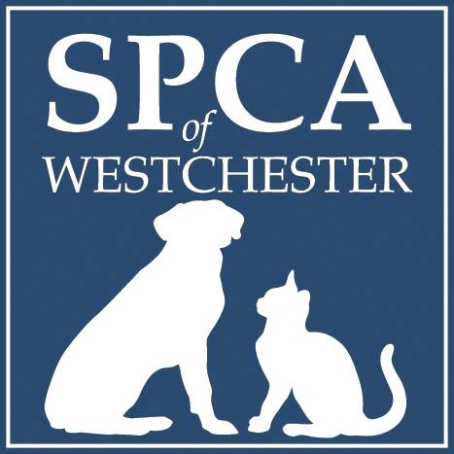

Protecting Animal Welfare
By Providing:
Shelter and Rehabilitation
Adoption Services
Low Cost Spay and Neuter
Cruelty Investigations
Outreach Programs
Help in Locating Lost Pets

SPCA of Westchester, Inc.
590 North State Road
Briarcliff Manor, NY 10510
(914) 941-2896
(914) 762-8312 fax
spca914.org

BOARD OF DIRECTORS

Deborah Klugman
Chairman
Mary Farley
Treasurer
Barbara Kobren
Secretary

Carolyn J. Gill
Nancy Karch
Lisa P. Rockefeller

EXECUTIVE DIRECTOR
Shannon Laukhuf

VETERINARIAN
Megan Caulfield, DVM

HUMANE LAW ENFORCEMENT
Ernest Lungaro, Chief

2021 SPCA Dog Walk & Adventure Day Sponsor Form
Date & Place: Your walk or adventure can be anywhere you choose-that’s the best part. We ask that you complete your walk or adventure now through Saturday, May 29th.

How does it work? Since we are unable to host our annual Dog Walk and Pet Fair in person, we are asking supporters to choose a special day to do something fun and active with your pet. This could be anything from a short walk or hike to a kayak outing or swim. Or, try some yoga with your cat companion. You decide and be creative!

Sponsors & Participants: While this special event has been modified due to Covid-19 we still need the generous support of Sponsors. We are also seeking walkers and adventurers to register online and fundraise by asking friends and family to sponsor their walk or adventure to raise funds for the SPCA animals.

Anyone who donates or raises $1,000+ will be given a VIP Insider’s Tour of our new animal care campus, set to open this summer!

Sponsors will be included in all or some of the following promotional materials to show our gratitude:

- SPCA email blasts (sent to nearly 25,000 animal lovers).
- SPCA website (average of 30,000 visitors a month).
- SPCA social media pages (more than 70,000 fans/followers).
- SPCA event mailing (nearly 10,000 supporters).

2021 SPCA Dog Walk & Adventure Day
Sponsor Levels:
$5,000 Beyond our Wildest Dreams Sponsorship
Benefits consist of:
- Name and/or logo will be featured as a premiere sponsor on all promotional materials. Please note, name(s) only will be listed on the event mailing. Name and logo/photos will be placed on all other materials including eblasts, social media and the SPCA’s website.

$2,500 Platinum Sponsorship
Benefits consist of:
- Name and/or logo will be listed as a top sponsor on all promotional materials. Please note, name(s) only will be listed on the event mailing. Name and logo/photos will be placed on all other materials including eblasts, social media and the SPCA’s website.

$1,000 Gold Sponsorship
Benefits consist of:
- Name OR logo will be listed on all promotional materials. Please note, name(s) only will be listed on the event mailing. Name and logo/photos will be placed on all other materials including eblasts, social media and the SPCA’s website.

$500 Silver Sponsorship
Benefits consist of:
- Name OR logo will be listed on all promotional materials excluding event mailing.

$250 Bronze Sponsorship
Benefits consist of:
- Name only will be listed on all promotional materials excluding event mailing.
Your Name AND Company:_____________________________________________________________

Street Address:_______________________________________Town:____________________________

State:________Zip Code: ____________ Phone: ___________________Email: ____________________
Beyond our Wildest Dreams $5,000 $____________
Platinum Sponsorship $2,500 $____________
Gold Sponsorship $1,000 $____________
Silver Sponsorship $500 $____________
Bronze Sponsorship $250 $____________
Enclosed is my check for $____________ (payable to SPCA of Westchester) or check here______if you made your Sponsorship donation online.
Charge my credit card: #_________________________________________Exp:________CVC Code:_______

Please send form along with payment information to: SPCA of Westchester at 590 North State Road, Briarcliff Manor, NY 10510. Questions? Call Lisa at (914) 941-2896 ext. 54 or email Lisa@spca914.org

