2020 Dog Walk Pledge Form
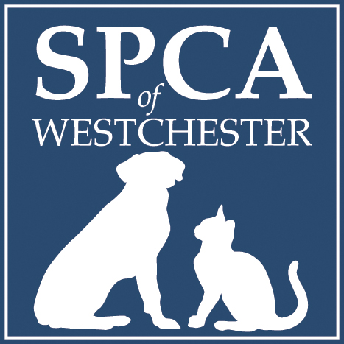

May 2nd from 10 am to 2 pm

*Bring this form with you to the event*
FDR State Park, Yorktown Heights, NY 10598

Questions? Contact: Lisa@spca914.org or (914) 941-2896 ext. 54
Details at SPCA914.ORG
Step One. Register!

Fill out the registration below and bring it with you the day of the event.

Walker (Your Name): ____________________________
Street: ________________________________________
Town: ________________State:____Zip Code:________
Email:____________________________

Step Two. Collect Pledges!
All participants are encouraged to collect donations in support of their walk for the animals. We accept checks made payable to the SPCA of Westchester, as well as cash.

1. Donor Name:___________________________________
Street:____________________________________________
Town:___________________ State:____ Zip Code_______
Amount Contributed: $__________Check____Cash___
Credit Card #___________________________________Exp.:_____ CVC Code:____

2. Donor Name:___________________________________
Street:____________________________________________
Town:___________________ State:____ Zip Code_______
Amount Contributed: $__________Check____Cash___
Credit Card #___________________________________Exp.:_____ CVC Code:____

3. Donor Name:___________________________________
Street:____________________________________________
Town:___________________ State:____ Zip Code_________
Amount Contributed: $__________Check____Cash___
Credit Card #___________________________________Exp.:_____ CVC Code:____
4. Donor Name:___________________________________
Street:____________________________________________
Town:___________________ State:____ Zip Code_________
Amount Contributed: $__________Check____Cash___
Credit Card #___________________________________Exp.:_____ CVC Code:____

5. Donor Name:___________________________________
Street:____________________________________________
Town:___________________ State:____ Zip Code_________
Amount Contributed: $__________Check____Cash___
Credit Card #___________________________________Exp.:_____ CVC Code:____

6. Donor Name:___________________________________
Street:____________________________________________
Town:___________________ State:____ Zip Code_________
Amount Contributed: $__________Check____Cash___
Credit Card #___________________________________Exp.:_____ CVC Code:____

7. Donor Name:___________________________________
Street:____________________________________________
Town:___________________ State:____ Zip Code_________
Amount Contributed: $__________Check____Cash___
Credit Card #___________________________________Exp.:_____ CVC Code:____

8. Donor Name:___________________________________
Street:____________________________________________
Town:___________________ State:____ Zip Code_________
Amount Contributed: $__________Check____Cash___
Credit Card #___________________________________Exp.:_____ CVC Code:____

9. Donor Name:___________________________________
Street:____________________________________________
Town:___________________ State:____ Zip Code_________
Amount Contributed: $__________Check____Cash___
Credit Card #___________________________________Exp.:_____ CVC Code:____

10. Donor Name:___________________________________
Street:____________________________________________
Town:___________________ State:____ Zip Code_________
Amount Contributed: $__________Check____Cash___
Credit Card #___________________________________Exp.:_____ CVC Code:____

